Carbody Structure and Exterior

Introduction

Use

Purpose

Parts List

All figures are assigned to an individual page unless views are required to show a complete listing of equipment.

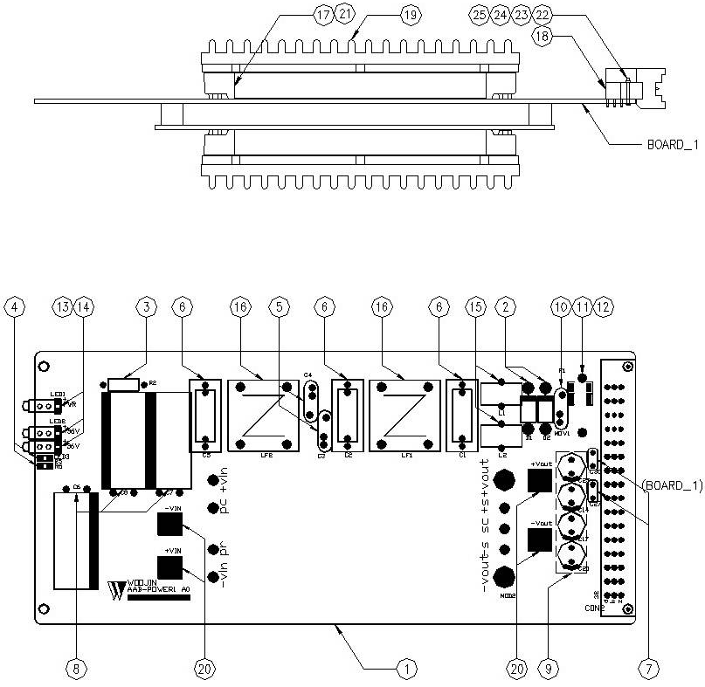

Figure 2.1. AAB Power Board1
Table 1 - Figure 2.1. AAB Power board1
FIG No. | PART NUMBERS |  |  | ITEM DESCRIPTION | VENDOR CODE | QTY
 | HRC | VENDOR | DTP
1 |  | AAB-POWER1 A0 |  | . BOARD, | HANSAEM | 1
2 |  | UF5408 |  | . FAST RECOVERY DIODE | RECTRON  VISHAY | 2
3 |  | CRS1/2W3.9KΩJTB  MGR371/2W3.9KΩJTP  RD1/2KT52R3.9KΩJ |  | . CARBON FILM RESISTOR | ABCO  RARA  JEIL | 1
4 |  | RC3216J562CS |  | . FILM CHIP RESISTOR | SAMSUNG | 2
5 |  | SDE2E472  HCFZ2G472MAAP10 |  | . CERAMIC CAPACITOR | SAMWHA  NETRONTECH | 2
6 |  | PCX2-335-MJ474  MPX474K31D5 |  | . FILM CAPACITOR | PILKOR  CARLI | 3
7 |  | PCMT-365-85104  EB1J104K |  | . FILM CAPACITOR | PILKOR  SAMHWA | 2
8 |  | KXL(NXB)63VB1000M7.5TP  RD1J108M16025PA |  | . ELECTROLYTIC CAPACITOR | SAMYOUNG  SAMWHA | 3
9 |  | KMG50VB220M5.0TP  RD1H227M1012MPE |  | . ELECTROLYTIC CAPACITOR | SAMYOUNG  SAMWHA | 4
10 |  | INR14D151  SVC151D-14A |  | . VARISTOR | AMOTECH  SAMWHA | 1
11 |  | 0215010.MXP  55T 250V 10A |  | . FUSE | LITTLE FUSE  ORISEL | 1
12 |  | FH51  GF205 |  | . FUSE HOLDER | YEONHO  GEO YOUNG | 1
13 |  | LS-SP150YG34-5 |  | . LED | LONGSUM | 3
14 |  | 7511A85 |  | . LED LIGHT PIPE | CML | 3
15 |  | 47uH/10A, Φ12, BLUE |  | . POWER INDUCTOR | TAESUNG  DAEKWANG | 2
16 |  | 2mH/6A, Φ27, RA |  | . LINE FILTER | TAESUNG  DAEKWANG | 2
17 |  | VI-920100B |  | . DC/DC CONVERTER | VICOR | 1
18 |  | 109-40064 |  | . RECEPTACLE | EPT | 1
19 |  | AI, D116 X L55 X H9 |  | . HEAT SINK | EGPOWER | 1
20 |  | ROUND, M3.5 X L8mm |  | . BOLT |  | 4
21 |  | ROUND, M3 X L10mm |  | . BOLT |  | 6
22 |  | ROUND, M2.6 X L12mm |  | . BOLT |  | 2
23 |  | HEXA, M2.6 |  | . NUT |  | 2
24 |  | FLAT, M2.6, D4.8mm |  | . WASHER |  | 2
25 |  | SPRING, M2.6, D4.8mm |  | . WASHER |  | 2

